OFFICIAL COORDINATION REQUEST FOR
NON-ROUTINE OPERATIONS AND MAINTENANCE

COORDINATION TITLE- 23BON018 Bradford Island Wetted Wall Camera Installation
COORDINATION DATE- 24 April 2023
PROJECT- BON
RESPONSE DATE-5 May 2023

Description of the problem –
Lamprey Passage Structures (LPS) are efficient mechanisms to facilitate dam passage for migrating adult Pacific lamprey (Entosphenus tridentatus) and have been deployed in a variety of locations and at several dams to help lamprey get through dams and out of fishways engineered specifically for salmon (Moser et al. 2011, Keefer et al. 2013). In 2017-2018 a specialized LPS, called a wetted wall (Fig. 1), was deployed to get lamprey out of the Bradford Island serpentine weir section of the fishway and into the makeup water supply channel which has an LPS system that is more efficient to pass lamprey through the Bradford Island section of Bonneville Dam (Frick et al. 2018; Appendix A). The wetted wall was developed, installed, and monitored for passage efficiency and efficacy. Monitoring was executed with video recordings of the system and required post-hoc examination of the footage to study the passage efficiency and behavior of the fish coming through the system and to allow enumeration of passage to study the efficacy of the system. The results indicated that fish utilize the wetted wall systems but had difficulty enumerating the fish coming through due to technical failures of the video recording equipment (Frick et al 2018).

The Fisheries Field Unit (FFU) would like to have a new camera installed at the Bradford Island Wetted Wall to monitor and validate optical sensor counts of lamprey passing. The installation would require the crew to work over the AWS of the fishway, between the picketed leads, using a lift-basket.

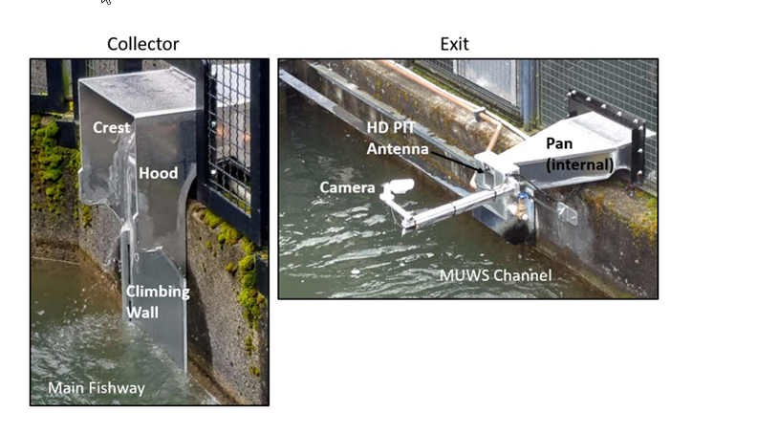
Figure 1. Wetted wall structure installed in 2017 and studied by Frick et al. 2018. Photo courtesy of K. Frick.
Type of outage required – None

Impact on facility operation

This operation will necessitate a deviation from the Bonneville Fish Passage Plan section 2.1.3 that states “Research, non-routine maintenance, fish-related activities, and construction will not be conducted within 100' of any fishway entrance or exit, within 50' of any other part of the adult fishway, or directly in, above, or adjacent to any fishway, unless coordinated with FPOM or FFDRWG by the Project, District Operations and/or Planning or Construction office. Alternate actions will be considered by District and Project biologists in conjunction with the regional fish agencies on a case-by-case basis.”

Dates of impacts/repairs – The project will be doing this work in the next couple of weeks.

Length of time for repairs – up to 4hrs

Analysis of potential impacts to fish

- 10-year average passage by run during the period of impact for adults and juvenile listed species, as appropriate for the proposed action and time of year; See Figure 2 and 3.

Figure 2. 10-year average of adult and jack Chinook passage at Bonneville

Figure 3. 10-year average of adult Steelhead passage at Bonneville.

- Statement about the current year’s run (e.g., higher or lower than 10-year average). The current year’s Chinook and steelhead runs are lower than the 10-year average see figures 4 and 5.

Figure 4. April 2023 Chinook passage at Bradford Island.

Figure 5. April 2023 Steelhead passage at Bradford Island.

- Estimated exposure to impact by species and age class (i.e., number or percentage of run exposed to an impact by the action); Chinook and some steelhead are passing this time of year. The most recent hourly counts for Chinook at Bradford Island ladder on 25 April ranged from 1 to 32 and Steelhead ranged from 0 – 1.

Table 1 Chinook and Steelhead most recent hourly counts for Bradford Island passage, April 24 and 25, 2023.

- Type of impact by species and age class (increased delay, exposure to predation, exposure to a route of higher injury/mortality rate, exposure to higher TDG, etc.); Possible delay due to noise exposure and general presence of workers over the water.

Summary statement - expected impacts on:
Impact to salmon passage from this work is expected to be minimal. It will not be overly loud or heavy in vibration and visitors already produce movement overhead of the fishway. Fish turned back by the presence of overhead movement (not directly overhead, this is the Auxiliary water system) would be expected to continue moving upstream after the work is completed, although with some delay. This behavior is commonly visually observed. Lamprey have not yet begun passing Bonneville, with the first fish expected to begin passing in the coming weeks. Impact to lamprey is expected to be even less than to salmonids.

Comments from agencies
CRITFC –
-----Original Message-----
From: Tom Lorz <lort@critfc.org>
Sent: Thursday, April 27, 2023 10:51 AM
To: Mackey, Tammy M CIV USARMY CENWP (USA) <Tammy.M.Mackey@usace.army.mil>
Subject: [Non-DoD Source] Re: FPOM: Official Coordination - 23BON018 MOC BI wetted wall camera installation

we are ok with the work, would suggest to do this late in the day to minimize impacts since passage is usually lighter later in the day.

thanks

Tom Lorz
________________________________

Final coordination results

Please email or call with questions or concerns.

Thank you,
Fisheries Field Unit

